

**Reference Based Compressed Sensing in MRI**

by

**Henry Hanh**

School of Information Technology and Electrical Engineering,

University of Queensland.

Submitted for the degree of Bachelor of Engineering (Honours)

in the division of Electrical Engineering.

12/06/2017

# Abstract

Table of Contents

Abstract 2

1.0 Introduction 5

2.0 Background Information 5

2.1 Magnetic Resonance Imaging and Acceleration techniques 5

**2.1.1** **Spatial Encoding and K Space Trajectories** 6

2.1.2 Image acquisition and K Space 7

2.1.3 Speed of MRI Scan 9

**2.1.3** **Full k - space acceleration scans** 10

2.1.3.1 Fast spin echo 10

2.1.3.2 Echo Planar Imaging (EPI) 10

**2.1.4 Partial k-space acceleration scans** 11

2.1.4.1 Partial Fourier Imaging 12

2.1.4.2 Parallel Imaging 13

2.1.4.3 Compressed Sensing 14

2.1.4.1.1 Sparsity 15

2.1.4.1.2 Sensing Matrix 16

**2.2** **Compressed sensing in MRI** 20

2.2.1 Transform Sparsity 20

2.2.2 Incoherent Sampling. 20

2.2.3 Variable Density Undersampling 21

2.2.4 Image Reconstruction 22

**2.3** **Current applications of Compressed Sensing in MRI** 23

**2.4** **Current Challenges to CS MRI** 24

**2.5** **Existing Image processing Techniques for MRI** 24

2.5.1 Edge Detection techniques 25

2.5.2 Canny Detection techniques 26

2.5.3 Image registration 27

2.5.4 Optimization-based image registration 28

2.5.5 Affine Transform 29

3.0 Experiment 30

3.1 Methodology 33

4.0 Results 34

5.0 Conclusion 35

6.0 Biblography 36

# Introduction

# Background Information

The purpose of Section 2 is to provide the necessary background information to understand the thesis itself. In Section 2.1 the basics of MR imaging and image formation will be explained. In Section 2.2 the fundamentals of Compressed Sensing will be reviewed. In Section 2.3 the requirements of Compressed Sensing and its applications will be presented. In Section 2.3 existing image processing techniques in reference to image registration will be explored.

## Magnetic Resonance Imaging and Acceleration techniques

MRI or (Magnetic Resonant Imaging) is a medical imaging technique which exploits the phenomena known as nuclear magnetic resonance. Nuclear magnetic resonance occurs due to nuclei of atoms possessing an inherent magnetic moment with an associated magnetic spin. These two quantities are dependent on the electron spin and orbital angular momentum of the atom. When a strong static magnetic field (B0)is applied, the nucleus of atoms will polarize and the magnetic moment aligns itself parallel to the static magnetic field. Applying a radio frequency (B1) of a particular frequency will disturb this orientation of magnetic moment and produce a magnetization component transverse to the static field. [1] Switching off this external radio frequency causes the nuclei to return to its externally imposed alignment and emit a detectable radio frequency. The frequency of the return RF signal is proportional to the static field strength. [3]

In MRI, the RF signals are generated by the hydrogen molecules found in the human body. These RF signals are detected by the receiver coils of the MRI machines. This process is illustrated below in Figure 2.1.

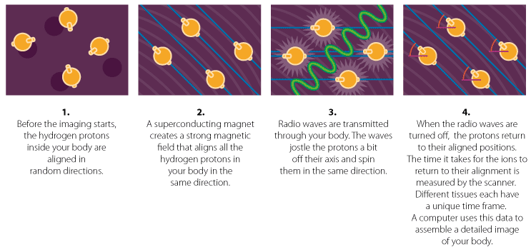

**Figure 2.1 MRI diagram**

At position , different physical properties of tissue proportionally influence the transverse magnetization. One influencing property is proton density however other properties may be emphasized as well. MRI reconstruction aims to visualize through depicting the spatial distribution of transverse magnetization.

## **Spatial Encoding and K Space Trajectories**

When the RF signal () is applied, the return RF signal detected by the coils in the MRI machines is the total RF signal to the region of interest where the static magnetic field is applied. For separate RF signals and hence location for protons, the protons of the hydrogen atoms can be manipulated through the use of gradient fields. A gradient field is an additional magnetic field in addition to the strong static field () to encode spatial information. By applying an additional magnetic field to a spatial position, the magnetization of protons in the spatial position will correspond to a precessing frequency and phase. Protons not exactly in the spatial position will vary slightly in frequency depending on the strength of the magnetic field. Through using at least two gradient fields, it is possible to find the location of the protons. [1]

MRI gradient fields vary linearly in space and are signified as , and which correspond to the three Cartesian Axes. Variations in the gradient fields cause location-dependant linear phase dispersion to occur. This allows for the MRI receiver col to detect a linear phase signal dependant on the location. It can be shown that [1] that the signal equation in MRI has the form of a Fourier Integral

Where . In words, this equation mean the received signal at time *t* is the Fourier transform of the object sampled at the spatial frequency

The MRI acquisitions method is based off the Gradient waveforms given by:

The gradient waveforms with the associated RF pulses used to produce magnetization, are called a pulse sequence.

### 2.1.2 Image acquisition and K Space

The construction of a single MR Image is found through collecting a series of frames of data, called acquisitions. In acquisitions, an RF excitation produced by magnets in the machine produces a new transverse magnetization which is them sampled along a trajectory in k-space.

The k-space is the 2D/ 3D Fourier transform of the MR image measured. It is a grid of raw data of the form ( (phase), (frequency)) obtained directly from the MR signal from MRI machine. Each point in the k space contains phase information and spatial frequency about every pixel in the final image. Conversely, each pixel in the MR image maps to every point in k-space. This concept can be seen below in Figure 2.2.

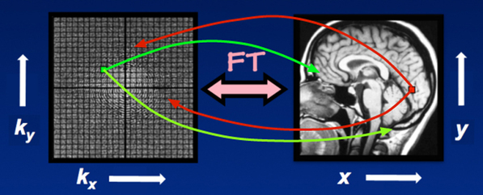

**Figure 2.2 The relationship between k-space and image domain [4]**

It should be noted that k-space trajectories/sampling patterns are designed to meet the Nyquist’s criterion which depends on the field of view. Under-sampling in k-space causes aliasing patterns. Some common k-space trajectories used by MRI machines are shown below in Figure 2.3.

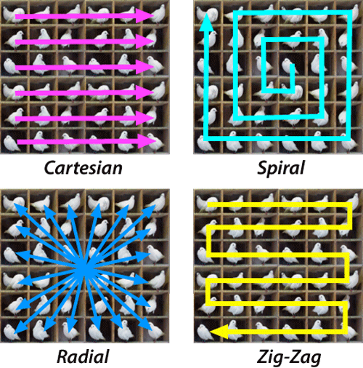

**Figure 2.3 typical k-space Trajectories used to fill k-space [5]**

The most common trajectory used by MRIs is the Cartesian Grid using a Cartesian sampling pattern. To get the MR image from Cartesian acquisitions, the inverse Fourier transform is applied to the k-space. For non-Cartesian trajectories different reconstructions techniques such as interpolation schemes (gridding) or back projection can be used. [1]

Using two gradient axes allows for spatial encoding in a 2D plane, known as a single slice of an MR image. For 3D images, multiple slices can be imaged to encode protons in a selected volume.

### 2.1.3 Speed of MRI Scan

The speed of MRI acquisition and consequently scan time of MRIs are directly correlated to the number of k-space measurements taken by the MRI scan. The speed of the MRI acquisitions by the MRI scan is limited by physical constraints such as the slew-rate and maximum amplitude. For high-resolution or wide field of vision images, a large number of k-space data is required to satisfy the Nyquist-Shannon criterion. [1] This results in lengthy scan times for patients. The rapid switching and high amplitudes of the gradient fields can also produce peripheral nerve stimulation. This may make patients uncomfortable and involuntarily move. Consequently, motion during the data acquisition results in motion artefacts in the final image which results in image quality degradation.

Motion artefacts come in many forms with the most problematic being motions from cardiac motion, respiratory motion, blood flow and gross body movement. These motions usually occur within a hundred milliseconds to several seconds. These intervals are usually equal or longer than the phase encoding sampling period, hence the majority of motion artefacts come in the phase encoding direction. The most common types of motion artefacts are image blurring and ghosting (misregistration). [6]

Image blurring occurs due to random movements which produce a noisy and blurry image. Periodic or ghost images occurs due to periodic movements such as respiration, cardiac beats and arterial or Cerebrospinal fluid pulsations. These types of motion artefacts are shown below in Figure 2.4.

To speed up the scan time, the two major methods to speed up the MRI scan time include accelerating the full k-space acquisition (Echo- Planar Imaging, fast spin echo) and partial acquisition methods of k-space (CS, Parallel imaging, Partial Fourier Imaging)

## **2.1.3** **Full k - space acceleration scans**

### 2.1.3.1 Fast spin echo

The conventional method to obtain k-space measurements would be applying a gradient axes to apply a 90 degree pulse and 180 degree pulse. The second pulse is to refocuses spins that have been dephased due to static field homogeneities and produces an echo to be measured by the receiver coils. The time between the centre of the first RF pulse and the peak of the spin echo is called the echo time (TE). The sequence repeats itself at the repetition time (TR). [8]

Fast spin echo uses multiple 180 degree pulses to follow each 90 degree pulse at each TR. At each 180 degree pulse a different phase-encoding gradient are is switched on together compared to the single phase-encoding gradient being turned on once each TR period. This allows for multiple lines in k-space (phase-encoding steps) to be collected within a given TR period. The number of echoes for each TR interval is known as the turbo factor or echo train length (ETL). The number of echoes acquired in a given TR interval is known as the echo train length (ETL) or turbo factor. Typically this ranges from 4-32 for routine imaging but may exceed 200 for rapid imaging/ echo planar techniques. [8]

FSE offers advantages such as increased SNR (signal noise ratio), reduced susceptibility-induced signal losses and quicker scan times. The major disadvantages of FSE is that it may introduce Gibbs ringing artefacts and image blurring in the phase-encode directions due to the inherent T2 decay during the formation of the echo train.

### 2.1.3.2 Echo Planar Imaging (EPI)

EPI (Echo Planar Imaging) involves applying spin-preparation module (which could be a single RF-pulse), a strong switched frequency-encoding gradient was applied simultaneously with an intermittently "blipped" low-magnitude phase-encoding gradient. This can be seen the Figure 2.5 below. As shown in Figure 2.5 the sequence results in a zig-zag transversal of the k-space.

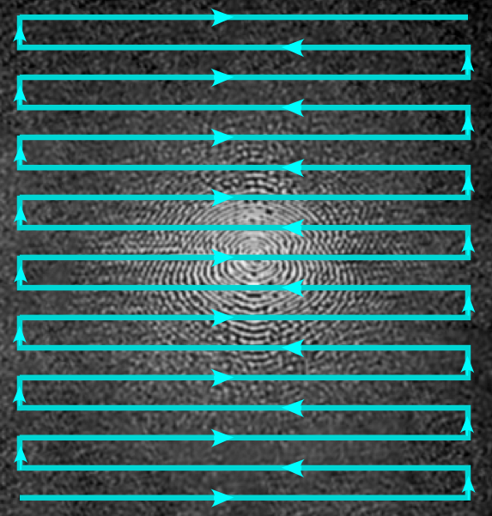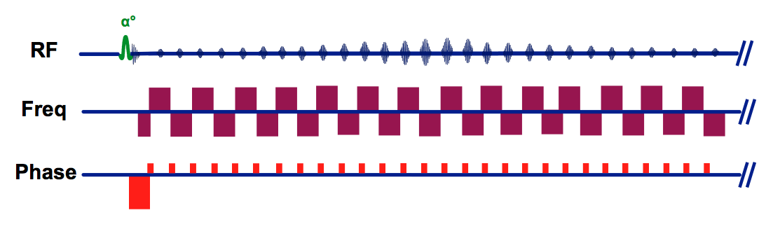

**Figure 2.5 (Top) RF pulse sequences (Bottom) Zig Zag k-space trajectory used in EPI**

This results in data from a 2D slice being able to collected following a single RF pulse. EPI can acquire slices within 50-100ms and decreases the motion artefacts due to patient motion due to its rapid imaging. A major disadvantage to EPI is its sensitive to inhomogeneity of main magnetic fields. Thus a high performance magnets are required by EPI to avoid gradient errors in imaging. [7]

## **2.1.4 Partial k-space acceleration scans**

These methods involve taking less measurements in the k-space to speed up the scan process. The three main methods of partial acquisition include Partial Fourier Sampling, Parallel Imaging and Compressed Sensing.

### 2.1.4.1 Partial Fourier Imaging

Partial Fourier Imaging exploits inherent property of the Fourier transform known as conjugate (or Hermitian) symmetry. Conjugate symmetry applies to pairs of points (P and Q) located diagonally from each other across the k-space origin. If the data P [a + bi] is a complex, the data at Q is the complex conjugate [a - bi]. This is illustrated in the figure below.

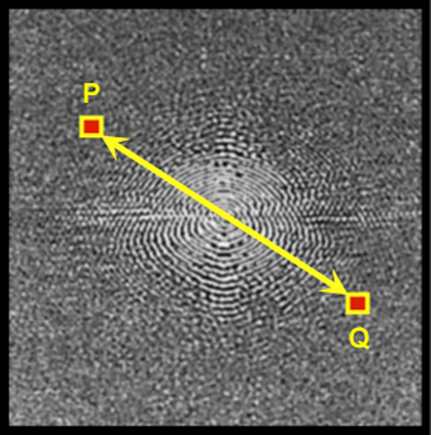

**Figure 2.6 Conjugate symmetry of k-space [10]**

Thus in theory, only half the k-space data needs to be collected the other half can be estimated using the conjugate symmetry property. The major methods of Partial-Fourier imaging are phase-conjugate symmetry and read-conjugate symmetry.

Due to the reduction in k-space measurements, there is up to a reduction in SNR (Signal Noise Ratio) by a factor of compared to the fully-sampled sequence. Source. Furthermore, any phase errors introduced from MR imaging will make symmetrical approximations not perfect.

### 2.1.4.2 Parallel Imaging

Parallel Imaging is the acquisition of under sampled k-space data from multiple coils that receive data from the same excitation. The multiple coils have localized sensitivities which are not homogenous over the image volume. The localized sensitivities for each coil are defined in well-known arrays known sensitivities maps. [11] This process is illustrated in Figure 2.7 below.

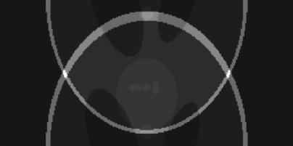

[a]

 

[b] [c]

**Figure 2.7 Example of an aliased image with two coil sensitivity maps. (a) Example of an aliased image. (b) Examples of two coil sensitivity maps. [11]**

When under sampled data is collected, it is done so in a predictable way which the reconstruction method chosen reconstructs a full field-of-view image without aliasing. This is done by under sampling (phase encoding lines) and sampling all (frequencies encoding lines) within these lines. [9] The two most common are Parallel Imaging techniques are SENSE (SENSitivity Encoding) which involves acquiring separate under sampled images from each coil and combining localized sensitivities to unfold the aliased signals mathematically and GRAPPA (GENERALIZED AUTOCALIBRATING PARTIALLY PARALLEL ACQUISITION). GRAPPA involves acquiring under sampled k-space data from coils and acquiring additional data near the centre of the k-space for calibration. This additional k-space data is used to calculate GRAPPA weights and subsequently the missing k-space data before the inverse Fourier Transform [9].

### 2.1.4.3 Compressed Sensing

The final method to speed up the MRI scan time using Partial Acquisition of k-space techniques is applying Compressed sensing to MRI

Compressed sensing involves solving the following mathematical problem:

where:

A is an m x n or sensing matrix which acquires m<<n measurements.

or the measurement matrix

or the N dimensional signal of interest we wish to reconstruct.

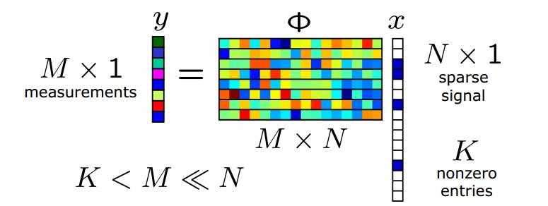And where m << n and is below the Nyquist-Whitter theorem for perfect reconstruction. This can be seen below in Figure 2.8

**Figure 2.8 Compressed Sensing Diagram.**

This mathematical equation is an underdetermined linear system with infinite solutions. For unique reconstruction, compressed sensing requires three elements that must be present: sparsity, sensing matrix and recovery algorithms.

### 2.1.4.1.1 Sparsity

For unique reconstruction, the signal is assumed to be sparse. A signal x is k-sparse when it has at most k nonzero or mathematically:

Where , ‖∙‖0 is the 𝑙0 norm. The formula for norms are explained in Appendix 1.

We let:

Denote the set of all k-sparse signals.

Typically, the signals to be reconstructed are not themselves sparse, but will be sparse in some basis Φ. In this case, will still be referred to being k-sparse, with the understanding that we can express x as x = Φc where Many sparisfying transforms (Φ) exist such as the Wavelet transform and Distcrete Cosine Transform. Both these transforms are used in widely used image formats such as MPEG and JPEG. This thesis will be using the Discrete Wavelet Transform to make the input signal sparse.

The Discrete Wavelet Transform is a multiscale representation of the image. Coarse-scale wavelet coefficients represent the low resolution image component and fine-scale wavelet coefficients represent high resolution components. Each

wavelet coefficient carries both spatial frequency and position information at the same time. [5] An example of the discrete wavelet transform can be seen below in Figure 2.9.

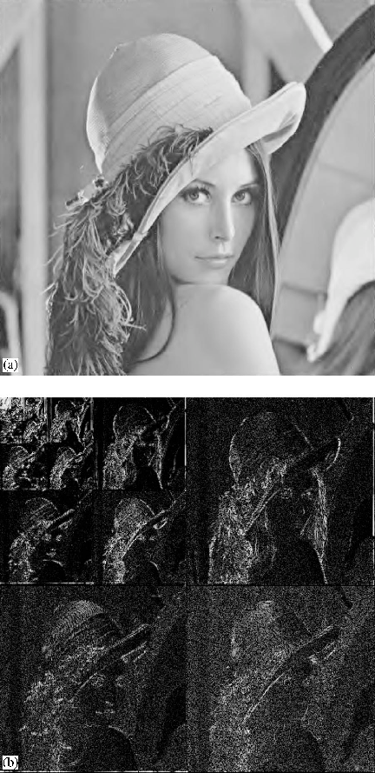

[a] [b]

**Figure 2.9 (a) Original Lena Image (b) Original Image with Wavelet Transform**

### 2.1.4.1.2 Sensing Matrix

The two major questions involving the design of the sensing matrix (A) is 1. How to design the sensing matrix A to ensure that it preserves the information in the signal 2. How can we recover the original signal from measurements . To ensure unique reconstruction, this section will provide the desirable properties that the matrix A should have for accurate recovery.

Null-space condition

To recover all sparse signals from or , then it is immediately clear that for any pair of distinct vectors, we must have , otherwise based of the measurements y, it will be impossible to distinguish from . Furthermore, if then with. Thus the matrix uniquely represents all if and only if the or the nullspace of A contains no vectors in . The nullspace is given as:

Many different ways exist to characterize this property, one of the most common is known as spark.

***Definition 2.1 The spark of a given matrix A is the smallest number of columns of A that are linearly dependent denoted as spark (A).***

Given an M x N matrix A, if spark(A) ∈ [2, m + 1], this guarantees the following:

***Theorem 2.1 For any vector y ∈ , there exists at most one signal x ∈ such that y = Ax if and only if spark(A) > 2k.***

When dealing with exactly sparse vectors, the spark provides a complete characterization of when sparse recovery is possible. When dealing with approximately sparse signals a somewhat more restrictive condition of the null-space is required.

***Definition 2.2 A matrix A satisfies the null space property (NSP) of order k if there exists a constant C > 0 such that,***

where Λ ⊂ {1, 2, . . . , N} is a subset of indices and = {1, 2, . . . , n}\Λ. is the length n vector obtained by setting the entries of h indexed by to zero. Similarly

to illustrate the implications of the NSP in sparse recovery, we can use the following thereom to measure the performance when dealing with general non-sparse x.

***Theorem 2.2 Let represent our specific recovery method and denote a sensing matrix. If ( , Δ) satisfies***

Where , then A must necessarily satisfy the NSP of order 2s.

The NSP of order 2s is sufficient to establish a guarantee of the form the previous algorithm to allow for practical recovery a practical recovery algorithm for all possible k-sparse signals.

**The restricted isometry property**

While the NSP is both sufficient and necessary for establishing of guarantees of the form (), these do not account for noise. When the measurements have been corrupted by some error such as quantization errors or noise, stronger conditions must be applied. In Cand`es and Tao [14] an isometry condition was introduced for matrix A.

***Definition 2.3: A matrix A satisfies the restricted isometry property (RIP) of order k if there exists a δk ∈ (0, 1) such that***

, for all x ∈ .

To any measurements vectors 𝒚𝟏=𝑨𝒙𝟏 and 𝒚𝟐=𝑨𝒙𝟐 𝒚=𝑨𝒙, RIP measures whether the distance between the two vectors is proportional to distinguish the correlated sparse signals 𝒙𝟏 and 𝒙𝟐.

If a matrix A satisfies the RIP of order 2k, thus A approximately preserves the distance between any pair of k-sparse vectors. This also allows to maintain the stability of solutions and recover a sparse signal from noisy measurements.

To achieve RIP the minimum number of measurements, measurement bounds are given below in the theorem.

***Theorem 2.3: Let A be an m × n matrix that satisfies the RIP of order 2k with constant δ ∈ (0, ].***

Then m ≥ Ck log ()

where C = 1/2 log(√ 24 + 1) ≈ 0.28.

<http://statweb.stanford.edu/~markad/publications/ddek-chapter1-2011.pdf>

As shown in source [13], RIP is strictly stronger than the NSP. The following theorem will prove that if a matrix satisfies RIP it also satisfies NSP.

***Theorem 2.4: Suppose that A satisfies the RIP of order 2k with < − 1. Then A satisfies the NSP of order 2k with constant.***

**Mutual coherence:**

While the spark, NSP and RIP provide guarantees for the recovery of k-sparse signals, to verify that any of these are satisfied has computational complexity, since each case must consider submatrices. It is more preferable to use properties of A that provide more concrete guarantees that are also easily computable. The mutual coherence is one such property.

***Definition 2.4: The mutual coherence of a given M x N matrix A, is the largest absolute inner product between two columns ,***

The lower bound is known as the Welch bound. When n>>m, the lower bound is approximately . The mutual coherence can be related to the RIP, NSP and spark by employing the Gershgorin circle theorem.

***Lemma 2.2 For any matrix A***

By combining Theorem 2.1 with Lemma 2.2 we can pose the following condition on A that guarantees uniqueness.

***Theorem 2.5 : if***

then for each measurement vector there exists at most one signal  such that

y = Ax.

Theorem 2.5 together with the Welch bound in Definition 2.4, provides an upper bound that guarantees uniqueness using coherence: .

Theorem 2.5 also connects mutual coherence to RIP as shown as follows:

***Lemma 1.5***: If A has unit-norm columns and coherence then A satisfied the RIP of order k with for all

Recovery Algorithm

## **Compressed sensing in MRI**

Due to the MR images being compressible and acquired in the Fourier domain, compressed sensing is able to be applied to MRI systems. Compressed sensing is successfully achieved through three fundamental requirements: transform sparsity, incoherence of under sampling artefacts and non-linear reconstructions.

### 2.2.1 Transform Sparsity

A certain signal can be recovered by applying Compressed Sensing if it is sparse in a known transform domain **Ѱ**. A signal is called nearly sparse or compressible when most of its elements are concentrated around zero. Many sparsifing transforms exist today such as the Wavelet Transform and the Discrete Cosine Transform. Such transforms are used in modern-day image video formats such as MP4 and JPEG2000. This thesis will focus on the use of the Wavelet transform to sparisfy the image data.

The Discrete Wavelet Transform is a multiscale representation of the image. Fine-scale wavelet coefficients represent high resolution image components and coarse-scale wavelet coefficients represent the low resolution image components. Each wavelet coefficient carries position information and special frequency at the same time.

### 2.2.2 Incoherent Sampling.

Due to undersampling violating Nyquist’s theorem, uniform under sampling exhibits coherent aliasing which may combine together and make signal recovery impossible. Applying incoherent sampling allows for strong sparse signal components to be detected and recovered through thresholding. The interference of these components are calculated and subtracted from original signal to recover the weaker sparse components.

To measure incoherence the equation in Definition 2.4 can be used. Completely random 2D sampling can be used in theoretical calculations however is unable to practically used due to the hardware and physiological constraints. Furthermore, sampling trajectories mostly follow relatively smooth curves and lines. However this does not naturally occur in random k-space sampling in all dimensions. The incoherent sampling patterns used in this thesis is the Variable Density Random under-sampling and the random phase encoding under-sampling. It should be noted that random sampling trajectories such as spiral and radial trajectories can also be used.

### 2.2.3 Variable Density Undersampling

For images in the wavelet domain, it can be observed that coarse-scale images components tend to be less sparse than fine-scale components. Furthermore, images have a concentration of energy closer to the k-space origin. This can be seen in the figure below:

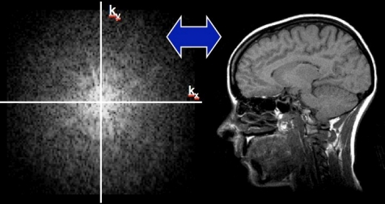

**Figure 2.10 (Left) Full sampled k-space data (Right) MRI in image domain. Most of the data is centred around origin of k-space. [15]**

Thus it can be concluded that for better performance with natural images, under sampling should occur less near the k-space origin and more in the peripheral of the k-space. This can be realized through choosing samples randomly with sampling density scaling according to the distance from the k-space origin. As shown in [source], using density powers of 1-6 greatly reduces the total interference and causes the iterative algorithm to produce better reconstruction and converge faster.

### 2.2.4 Image Reconstruction

For conventional reconstruction of CS MRI images, the following constrained optimization problem must be solved:

Minimize:

Such that:

Where:

𝜓 is the linear operator which transforms the pixel representation into a sparse representation

𝑦 is the measured data of the MRI.

𝐹𝑢 is the under sampled Fourier transform, corresponding to a k-space undersampling scheme.

𝑚 is the image to be reconstructed.

ϵ is the typically the expected noise level which controls the fidelity of the reconstruction of MRI data.

The minimization of the l1 norm promotes sparsity whilst the minimization of l2 norm promotes data fidelity. When finite-differences is used as a sparsifying transform the objective function is referred to as Total-Variation (TV), since Total Variation is the sum of the absolute variations of the image. It is often useful to also include a TV penalty as well as the sparsifying transform in the objective function. This allows for the reconstructed image to be sparse in both the finite-differences and specific transform at the same time. Thus the previous equation can be rewritten as:

Minimize:

Such that:

Minimizing the l1 norm is crucial to the whole objective function. Various methods to solve the equation such as homotopy, iterative soft thresholding and iteratively reweighted least squared. The conventional algorithm (SPARSE-MRI) which solves the previous equation is described in appendix using non-linear conjugate gradients and backtracking line-search.

## **Current applications of Compressed Sensing in MRI**

Due to the relatively new nature and disadvantages of Compressed sensing in MRI, it is currently not applied to many clinical MRI scans. According to source compressed sensing has the potential to be applied to the following areas:

* Rapid 3D Angiography- Angiography is important for diagnosis of vascular disease. Often, a contrast agent is injected, significantly increasing the blood signal compared to the background tissue. For high temporal and spatial resolution of a large FOV, MR angiography scans are often under sampled to reduce scan times. To reduce aliasing artefacts from under sampling Compressed Sensing may be applied.
* Whole-Heart Coronary Imaging- X-ray coronary angiography is the gold standard for evaluation coronary artery disease but it is invasive [16] . Multislice X-ray CT is a non-invasive alterative but requires high doses of ionizing radiation. MRI is emerging as a non-invasive, non-ionizing alterative. Coronary arteries are constantly in motion, making high-resolution imaging a challenging task. To minimize the effects of breathing the scan can be tracking and compensating for respiratory motion. The effects of heart motion can be minimized by synchronizing acquisitions to the cardiac cycle. In current scans, the number of acquisitions is limited to the number of cardiac cycles in the breath-hold period. However with applying compressed sensing, the scan time can be decreased significantly. [17]
* Brain Imaging – Brain scans are the most common applications to MRI. Most brain scans use 2-D Cartesian Multi-slice acquisitions. The Sparsity/Compressibility of MR Images showed that brain images exhibit transform sparsity in the wavelet domain. Applying Compressed Sensing allows for reduction of collection time while improving the resolution of current imagery.

## **Current Challenges to CS MRI**

Although many successful applications of Compressed sensing in MRI, conventional CS MRI has many challenges which allow it to be incapable to provide diagnostically accurate images in some imaging cases. These include:

* Design of random acquisition method of allow for incoherent undersampling- Random 2D undersampling is difficult to achieve due to the required rapid gradient switching being constrained by hardware.[source] Furthermore the resulting artefacts and eddy currents may significantly degrade the quality of reconstructed image. A more practical method would be to apply random phase-encoding, however this introduces aliasing artefacts. Other non-Cartesian trajectories exist (e.g. radial) however are not commonly implemented in routine clinical use.
* Reduction factors of Compressed Sensing- For compressed sensing to be practically implemented, compressed sensing must at least be greater than the reduction factor of 3 for Parallel Imaging. The reduction factor is defined as (R = , where D is the total number of points defining the grid and N is the number of samples taken). Currently implementing Compressed Sensing at higher reduction factors introduce aliasing artefacts and blur edges due to reconstruction errors. This has limited the potential use of Compressed Sensing in further applications.

## **Existing Image processing Techniques for MRI**

In some types of MRI scans (e.g. dynamic MRI and 3D MRI images) multiple images are taken of the same region of interest to produce the reconstructed image. Some of the images taken have the same information (e.g. edges, structure and physiology) and can be used to reconstruct the next image taken. An example can be seen below in Figure 2.11. This information may 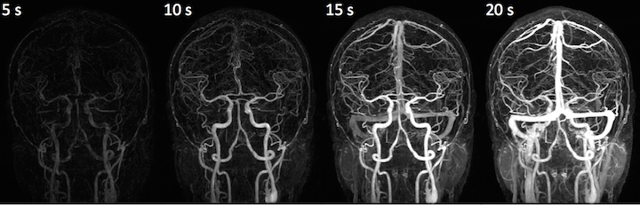potentially be able to improve the image quality or reduce the scan time of the next image taken.

**Figure 2.11**

As shown in the dynamic MRI scans of the brain as the contrast agent reveals the blood vessels, which are present in all the images at higher contrasts depending on time

Currently many image processing techniques exist in edge detection and image registration which may be used in gathering information from a reference or previous image.

### Edge Detection techniques

An edge in an image is significant local change in the image intensity, usually association with a discontinuity in the first derivative of the image intensity or the image intensity.[19] Edges are important image features as they may correspond to significant features in the image. In MRI this is relevant as some types of MRI images are sparse (e.g. Angiography scans) and edges provide information on patient physiology.

To detect edges the following steps must be applied [19]:

1. Filtering- Since the gradient computation based on intensity values of two points are influenced by noise and other vagaries in discrete computation, an image filter is commonly applied to improve performance of edge detector.
2. Enhancement – In order to detect edges, the changes in intensity in the neighbourhood of a point must be determined. Enhancement of edges emphasizes pixels where there is a significant change in local intensity values. This is usually performed by computing the gradient magnitude.
3. Detection- Many points in an image have a non-zero value for the gradient and thus not suitable for edges in a particular application. Therefore a method should be used to determine which points are edges

Many edge operators also include this fourth step although not all edge detectors.

1. Localization- The location of the edge can be estimated with subpixel resolution if required for the application. The edge orientation can also be estimated.

Many edge detectors have been developed such as the Roberts Operator, Sobel Operator and Prewitt Operator. One of the popular edge detectors used currently is the Canny edge detector.

### Canny Detection techniques

The steps of the Canny Edge detector as shown below [19]:

1. A Gaussian filter is applied to smooth the image in order to remove the noise. This involves convolving a typically 5x5 Gaussian filter to the image.
2. Find the intensity gradients of the image - This involves filtering the smoothened image in both the horizontal and vertical directions using the Sobel operator to get the first derivative in horizontal () and vertical (). The Edge gradient and angle are then found for each pixel.
3. Apply non-maximum suppression to get rid of spurious response to edge detection. Pixels are checked if it is a local maximum in its neighbourhood in the direction of the gradient. Non maximum values are suppressed to zero.
4. Apply double threshold to determine potential edges. A double threshold on intensity gradients is applied on edges to determine potential edges.
5. Track edges by hysteresis – Edges that are not connected to “sure-edge” pixels (higher than the maximum threshold value) are discarded.

An example of the Canny Filter operation is illustrated in Figure 2.12.

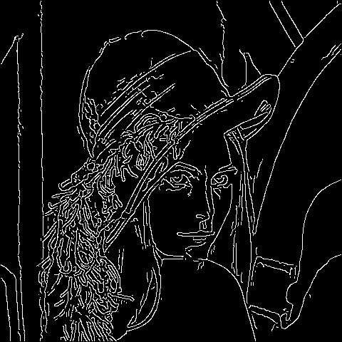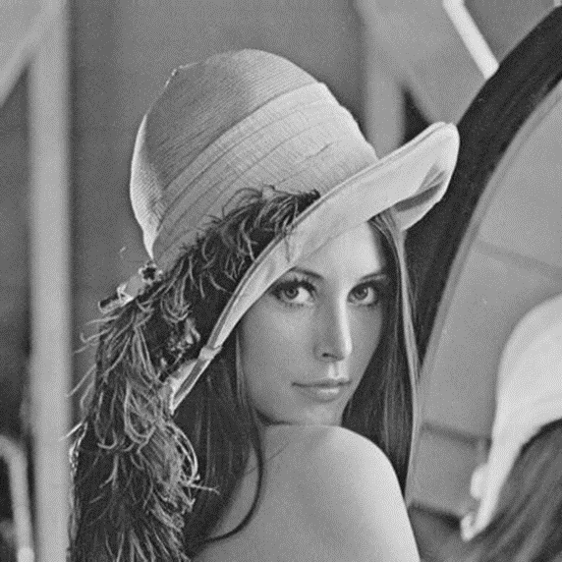

**Figure 2.12 (Left) Original Image (Right) Edges detected after applying Canny Edge Detector**

### Image registration

To use the data from previous or reference image, we must image register the reference image with the new image. This process is known as image registration. Image registration involves spatial align two images so that corresponding points assume the same coordinates. This involves having two images, a reference image and sensed image. The reference image is kept unchanged and the sensed image is transformed to take the geometry and spatial coordinates of the reference image. The basic steps of image registration is shown in the Figure 2.12 [20]:



**Figure 2.12 Basic Steps of Image Registration Diagram**

* Feature detection: Salient and distinctive objects (line intersections, edges, contours, corners, and closed-boundary regions etc) in both reference and sensed images are detected.
* Feature matching: The correspondence between the features in the reference and sensed image established.
* Transform model estimation: The type and parameters of the so-called mapping functions, aligning the sensed image with the reference image, are estimated.
* Image resampling and transformation: The sensed image is transformed by means of the mapping functions.

There are two classifications of image registration Feature Based image registration techniques and Intensity Based image registration techniques. Intensity based image registration techniques use the structure of the image via correlation metric, structural analysis and Fourier properties. Alternatively, most feature based methods map the images via correlation of image features: points, curves, lines, boundaries and line intersections, etc. [21]

According to [22], the best method of image registration for MRI applications is to use intensity based registrations.

Source [22] goes into detail the different types of image registration techniques. The technique which will be focussed on this current thesis will be the optimization registration technique using affine transformations.

### Optimization-based image registration

A registration may be considered optimal if it maximises a measure of similarity or minimizes a measure of dissimilarity between images. In optimization-based image registration the following are required:

1. The similarity/dissimilarity measure between images are defined
2. The initial parameters that approximately register the images are defined.
3. An algorithm is developed to take the initial registration to the final registration.

The similarity/dissimilarity measure is chosen based on the properties of the images. The initial parameters may be determined automatically specified interactively or automatically. An automatic method achieves the same result without user interactions. An interactive method allows for users to drag one image over to the other to approximately align them. The initial registration parameters are then refined iteratively until optimal registration is reached. The refinement or optimizer step involves measuring the similarity/dissimilarity between registered images and revising the registration so each iteration either increases similarity or decreases dissimilarity [22].

### Affine Transform

Many image transforms currently exist to register two images together. Some of the most common image transforms include Rigid, Projective, Curved and Affine Transforms. [22] To preserve the structure and collinearity of the sensed image Affine Transformations are one of the most suitable and flexible transforms to apply to image registration.

An affine transformation is any transformation that preserves collinearity (i.e., all points lying on a line initially still lie on a line after transformation) and ratios of distances (e.g., the midpoint of a line segment remains the midpoint after transformation). Some common affine transforms are shown below in Figure 2.14:

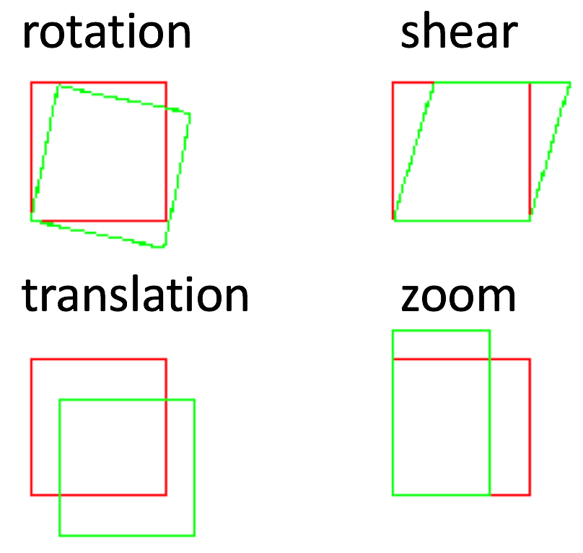

**Figure 2.14 Typical Affine Transforms using in this thesis**

# Experiment

## Introduction

Magnetic Resonance Imaging (MRI) is a widely used medical imaging technique which uses nuclear magnetic resonance to acquire images in Fourier domain. The major challenge to MRI currently is the long scan times required to produce high resolution or large FOV MR images. This is limited due to the physical and physiological constraints.

To speed up the process Compressed Sensing can be applied to MRI as it allows for the under-sampling of the k-space to faithfully reconstruct images. As outlined in section it does this through satisfying three requirements: sparsity, incoherent under sampling and non-linear reconstruction methods. Wavelet, TV and L1 minimization.

Currently, the conventional method (Sparse MRI) does not use prior information from a previous image to speed-up acquisition or improve image reconstruction. However, in many types of MRI scans this information is available and may potentially be used. Such applications include the following:

1. Dynamic MRI, Diffusion MRI- Multiple images are acquired at a single imaging session. This allow for exploitation of similarity along the temporal(time domain)
2. Multi-contrast MRI- Scanning of region with different contrasts (T1 and T2 weighted images). Structural similarities exist between the images which are able to enchance image reconstruction.

Referenced based compressed sensing has be explored a lot over the past few years in various applications of MRI. Current methods which use a reference based approach are listed in the table below.

|  |  |  |
| --- | --- | --- |
| **Author** | **Description** | **Imaging application tested** |
| Liang and Lauterbur (Ref. 44) | Exploiting temporal similarity in dynamic MRI using generalized scheme imaging | Dynamic MRI (dynamic T1-weighted and diffusion MRI) |
| Hanson et al. (Ref. 11) | Exploiting two high resolution reference images to improve dynamic imaging in a generalized scheme | Dynamic MRI (DCE MRI) |
| Hess et al. (Ref. 12) | Exploiting reference image for generation of basis functions, used to improve dynamic MRI | Dynamic MRI (MR angiography) |
| Tsao et al. (Ref. 32) | Incorporating reference image and prior on changed regions for improved reconstruction | Longitudinal MRI |
| Tsao et al. (Ref. 45) | Exploiting spatiotemporal correlations for dynamic MRI (training-based approach) | Dynamic MRI (cardiac imaging) |
| Lustig et al. (Ref. 16) | Random sampling in *k*-*t* space, reconstruction based on wavelet-Fourier sparsity | Dynamic MRI (cardiac imaging) |
| Haldar et al. (Ref. 46) | Using anatomical priors to improve SNR via penalized ML | Single-contrast MRI |
| Lang and Ji (Ref. 17) | Exploiting similarity to a reference image in a CS framework | Dynamic MRI (brain DCE) |
| Gamper et al. (Ref. 18) | Exploiting sparsity in the *x*-*f* space for dynamic MRI | Dynamic MRI (cardiac imaging) |
| Jung et al. (Ref. 19) | Exploiting sparsity of residuals in dynamic MRI | Dynamic MRI (cardiac imaging) |
| Yun et al. (Ref. 13) | Exploiting a reference image for basis functions generation used to improve dynamic MRI | Dynamic MRI (brain fMRI) |
| Samsonov et al. (Ref. 33) | Exploiting sparsity of gradient of difference between baseline and follow-up scans | Longitudinal MRI |
| Chen et al. (Ref. 20) | Exploring the exploitation of a reference frame in x-t and x-f domains in dynamic MRI | Dynamic MRI (cardiac imaging) |
| Wu et al. (Ref. 24) | Using noisy reconstruction as a reference for sorting in parallel imaging | Single-contrast MRI |
| Peng et al. (Ref. 25) | Exploiting reference image for sparsifying transform generation | Single-contrast MRI |
| Bilgic et al. (Ref. 28) | Exploit similarity of spatial derivatives in multicontrast MRI | Multicontrast MRI |
| Du and Lam (Ref. **26**) and Lam *et al.* (Ref. **27**) | Exploiting similarity to a reference image in a CS-based hybrid reconstruction and registration scheme | Single-contrast MRI |
| Nguyen and Glover (Ref. 14) | Exploiting a reference image for generation of basis functions used for generalized series reconstruction of dynamic MRI | Dynamic MRI (brain fMRI) |
| Haldar et al. (Ref. 15) | Using structural MRI for SNR improvement of DWI in an ML scheme | Diffusion MRI |
| Qu *et al.* (Refs. **29** and **30**) | Exploiting similarity of image patches within and between multicontrast MRI in CS framework | Multicontrast MRI |
| Huang et al. (Ref. 31) | Joint TV and group wavelet based reconstruction for multicontrast MRI | Multicontrast MRI |
| Chiew et al. (Ref. 21) | Low-rank based reconstruction | Dynamic MRI (brain fMRI) |
| Li et al. (Ref. 34) | Using nonreference-based reconstruction as a prior for reference-based reconstruction | Longitudinal MRI |
| Adluru et al. (Ref. 22) | Exploiting TV-based reconstruction for improved low-rank based reconstruction | Dynamic MRI (cardiac imaging) |
| Otazo et al. (Ref. 23) | Low-rank based reconstruction | Dynamic MRI (cardiac imaging, MR angiography) |
|  | Exploiting reference image in an adaptive-weighted CS scheme | Single- and Multi-Contrast MRI, Longitudinal MRI |

From closer inspection of the existing methods, the reference based methods are application specific and assume substantial similarity in image or other domain.

Similar to previous methods, this thesis aims to introduce a novel method to use previous information from a previous similar reference image to enhance the image reconstruction. The similarity is assumed to be in the image domain.

The proposed method will use the CS framework proposed in [1] and include weighting factors for both the L1 and TV components. In this new algorithm the image will be reconstructed first using algorithm in [1] and then a reference image will processed and its edges will be determined. Using this edge information, the reconstructed image will be image registered with the edges. The weighting factors of the L1 and TV weightings on edge components will then be optimized to account prior information. Using the new weighting factors, the image will then be reconstructed again. To demonstrate the performance of the proposed method, various typical images, multi-contrast images will be used at reduction factors up to 10. Using structural similarity (SSIM) and peak signal-to-noise ratio (PSNR) as image quality metrics, the proposed method was compared with the conventional method.

## Methodology

## Conventional CS MRI

As mentioned in Section CS MRI, the standard can be mathematically described as follows.

Where denotes the sparse transform, the 𝑦 is the measured data of the MRI, 𝐹𝑢 is the under sampled Fourier transform, ϵ is the typically the expected noise level and m is MR image to be reconstructed. 𝒙∈𝑪M×N

It can be noted that the conventional method does not account for any image-based prior information that exists in many MRI applications.

## Similarities in MR images

As mentioned in section 2.5 different applications of MR have substantial similarities (i.e. edges, structure and physiology) which can be used to enhance image quality. For example This similarity can be in Multi-contrast images where the edges recovered when applying a Canny filter is almost identical. This can be seen below in diagram…. This edge information will be used to alter the weighting factors through weighting masks.

## Weighting Factors

Weighting factors huge role in the overall image quality in the reconstruction process. As researched earlier in the semester the L1 and TV weighting factors the reconstruction algorithm. The l1 minization occurs using conjugate back-tra

Weighting Mask

## Image Registration- Optimization Algorithm

## Proposed Method

## Experimental Method

## Results

## Comparison

## Discussion

## Conclusion

# Results

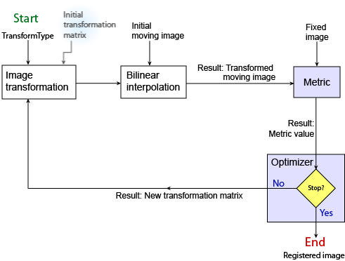

# Conclusion

# Biblography

[1] M.Lustig, D.Donoho, J.M.Pauly, Compressed Sensign MRI, IEEE Processing Magaine, 2007:p.72-81

[2]"Concept :: How MRI Works :: Jeffery West Design Information Design and Illustration Visualize, Communicate, and Make Yourself Understood", *Jwestdesign.com*, 2017. [Online]. Available: http://www.jwestdesign.com/concept/concept-3.html. [Accessed: 03- Jun- 2017].

[3] M. Elmaoğlu, A.Celik, MRI Handbook: MR Physics, Patient Positioning, and Protocols, New York, USA, Springer, 2012, ch 3

[4]A. Elster, "k-space", *Questions and Answers ​in MRI*, 2017. [Online]. Available: http://mri-q.com/what-is-k-space.html. [Accessed: 03- Jun- 2017].

[5]A. Elster, "k-space: trajectories", *Questions and Answers ​in MRI*, 2017. [Online]. Available: http://mriquestions.com/k-space-trajectories.html. [Accessed: 03- Jun- 2017].

[6] Z.P. Liang and P. C. Lauterbur. Principles of Magnetic Resonance Imaging: A signal Processing Perspective, 2000.

[7]A. Elster, "Echo-planar imaging (EPI)", *Questions and Answers ​in MRI*, 2017. [Online]. Available: http://mriquestions.com/echo-planar-imaging.html. [Accessed: 03- Jun- 2017].

[8]A. Elster, "TSE/FSE", *Questions and Answers ​in MRI*, 2017. [Online]. Available: http://mriquestions.com/what-is-fsetse.html. [Accessed: 03- Jun- 2017].

[9]A. Deshmane, V. Gulani, M. Griswold and N. Seiberlich, "Parallel MR imaging", *Journal of Magnetic Resonance Imaging*, vol. 36, no. 1, pp. 55-72, 2012.

[10]A. Elster, "Partial Fourier", *Questions and Answers ​in MRI*, 2017. [Online]. Available: http://mriquestions.com/partial-fourier.html. [Accessed: 03- Jun- 2017].

[11] A. Majumdar, R. Ward and K. Iniewski, *MRI: Physics, Image Reconstruction, and Analysis*, 1st ed. Florida, United States of America: CRC Press, pp. 93-104.

[12] M. Davenport, M. Duarte, Y. Eldar and G. Kutyniok, "Introduction to Compressed Sensing", *Stanford Department of Statistics*, 2011. [Online]. Available: http://statweb.stanford.edu/~markad/publications/ddek-chapter1-2011.pdf. [Accessed: 03- Jun- 2017].

[13] E. Cand`es, J. Romberg, and T. Tao. Stable signal recovery from incomplete and inaccurate measurements. Comm. Pure Appl. Math., 59(8):1207–1223, 2006.

[14] E. Cand`es and T. Tao. Decoding by linear programming. IEEE Trans. Inform. Theory, 51(12):4203–4215, 2005.

[15] <https://med.stanford.edu/bmrgroup/Research/AcqRecon.html>

[16] M. Lustig, D. Donoho, J. Santos and J. Pauly, "Compressed Sensing MRI", *IEEE Signal Processing Magazine*, vol. 25, no. 2, pp. 72-82, 2008.

[17] "Compressed Sensing - Siemens Healthineers Australia", *Healthcare.siemens.com.au*, 2017. [Online]. Available: https://www.healthcare.siemens.com.au/magnetic-resonance-imaging/mri-technologies/speed-technologies/compressed-sensing/body-imaging. [Accessed: 04- Jun- 2017]

[18] (<http://mrcentre.ca/Our_People/mlebel>)

[19] R. Jain, R. Kasturi and B. Schunck, *Machine vision*, 1st ed. New York [u.a.]: McGraw-Hill, 1995.

[20] M. Wyawahare, P. Patil and H. Abhyankar, "Image Registration Techniques: An overview", *International Journal of Signal Processing, Image Processing and Pattern Recognition*, vol. 2, no. 3, pp. 11-28, 2017.

[21]S. Boda, "FEATURE-BASED IMAGE REGISTRATION", Master of Technology, National Institute of Technology Rourkela, 2017.

[22]A. Goshtasby, *Image Registration: Principles, Tools and Methods (Advances in Computer Vision and Pattern Recognition)*, 1st ed. London: Springer Verlag London Ltd, 2012, pp. Chapter 1, 11.

[17]E. Weisstein, "Affine Transformation -- from Wolfram MathWorld", *Mathworld.wolfram.com*, 2017. [Online]. Available: http://mathworld.wolfram.com/AffineTransformation.html. [Accessed: 04- Jun- 2017].